Testing Report for Library Management System

Dinesh Devkota
Modern Institute of Technology (MIT)
CSE220: Principles Of Software Engineering
Professor Poshan Karki
August 7, 2026

Introduction
Software testing is a crucial part of the Software Development Life Cycle (SDLC) that guarantees a system performs according to its defined requirements. Testing is effective in the detection of defects, system reliability and user satisfaction, before deployment. This report details the testing activities carried out for the Library Management System which was developed in the requirement analysis and design phase. This report concentrates on the User Registration and Login modules, which are essential functions that enable users to log into the library services safely.
This test report aims to create and record extensive test cases that test the system's behavior under valid and invalid conditions. Different testing methods were also taken into consideration for the sake of the functional testing of the system and to make sure it does what it should. These methods are: Unit testing, Integration testing, System testing, User acceptance testing. Test scenarios were designed both positively and negatively, to ensure that the system's robustness and error handling were valid.
Testing Strategy
A testing strategy was created from the system requirements identified in the analysis and design. Various aspects of the system were evaluated with a combination of testing levels. The following functions were individually test in the unit: field validation, password checking etc. The interaction between the registration and login modules and the database were tested. System testing was conducted to test the total functionality of user authentication and User Acceptance Testing (UAT) was conducted to check whether or not the user authentication system is fulfilling the requirement of business and user.
Positive test cases were written to ensure the system performs correctly when valid inputs are inputted. Negative test cases were also designed to check for invalid inputs, missing data, and invalid credentials. This approach will help keep the system quality, reliability and security.
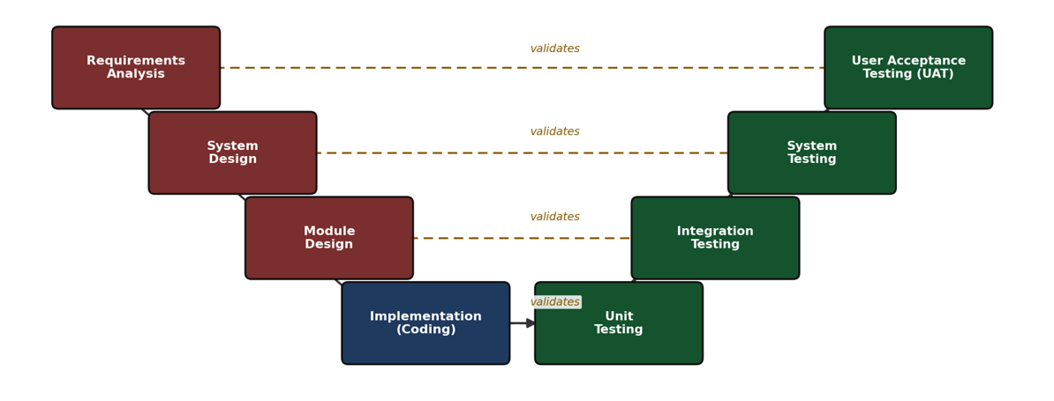

Test Schedule
Phase | Dates | Duration
Unit testing | Aug 3 – Aug 4, 2026 | 2 days
Integration testing | Aug 5 – Aug 6, 2026 | 2 days
System testing | Aug 7 – Aug 8, 2026 | 2 days
User Acceptance Testing (UAT) | Aug 10 – Aug 12, 2026 | 3 days
Defect fixes and retest (planned) | Aug 13 – Aug 15, 2026 | 3 days

Test Case Design Summary
A total of 34 test cases were designed and executed: 10 unit, 8 integration, 8 system, and 8 UAT, split 22 positive / 12 negative. Results below are drawn directly from the Summary sheet of LMS_Test_Cases.xlsx.
Test level | Total | Pass | Fail | Pass rate
Unit | 10 | 9 | 1 | 90.0%
Integration | 8 | 7 | 1 | 87.5%
System | 8 | 7 | 1 | 87.5%
UAT | 8 | 7 | 1 | 87.5%
Total | 34 | 30 | 4 | 88.2%
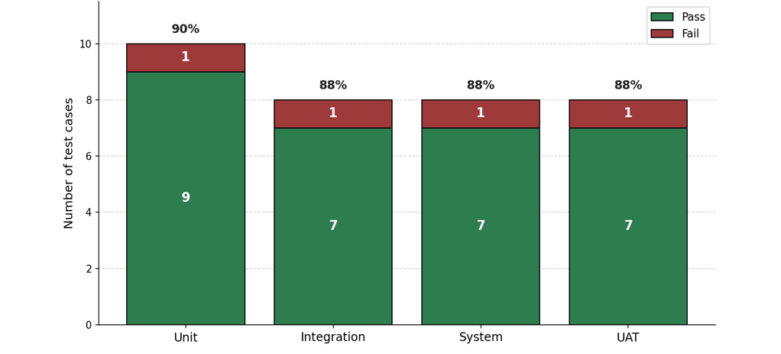

Representative Test Cases
The ten test cases below are a representative sample spanning all four levels and both scenario types of the full 34-case suite in LMS_Test_Cases.xlsx.
ID / Level | Objective & Input | Expected Output | Actual Output | Status
TC-U-06  Unit (Pos.) | Book-availability function reports an available copy correctly. Input: title/branch with an unborrowed copy. | Function returns Available: true. | Returned Available: true. | Pass
TC-U-02  Unit (Neg.) | Reject registration with missing address. Input: name/phone filled, address blank. | Save blocked; 'Address is required' shown. | Save blocked; correct message shown. | Pass
TC-U-03  Unit (Neg.) | Reject an invalid ISBN. Input: ISBN = '12-XYZ-not-real'. | Save blocked; 'Enter a valid ISBN' shown. | Save proceeded; invalid value was stored. | Fail
TC-I-03  Integration (Neg.) | Block checkout for a member with unpaid fines over the $15 threshold. Input: checkout attempt with $22 owed. | Checkout blocked; 'Clear outstanding fines first' shown. | Checkout proceeded; book was issued. | Fail
TC-I-05  Integration (Pos.) | Returned book updates catalog availability immediately. Input: check-in of a previously borrowed copy. | Copy shows Available immediately in catalog search. | Appeared immediately with correct status. | Pass
TC-S-02  System (Pos.) | Prevent simultaneous double-checkout of one physical copy. Input: 2 clerks check out same copy at once. | Only one checkout succeeds; other gets conflict message. | Only Clerk A succeeded; Clerk B received conflict message. | Pass
TC-S-06  System (Neg.) | Hold-expiry handling for a pickup window <24h. Input: hold expiring 18 hours out. | Immediate confirmation sent; 24h reminder skipped without error. | Confirmation sent; reminder skipped, but an error was logged unnecessarily. | Fail
TC-A-01  UAT (Pos.) | Front-desk clerk registers a walk-in patron unassisted. Input: real walk-in patron details. | Completed correctly within 3 minutes, unassisted. | Completed in 2 min 45 sec, unassisted. | Pass
TC-A-06  UAT (Pos.) | Branch manager generates/exports weekly circulation report. Input: 1 week of checkout/return data. | Report generates and exports successfully with correct totals. | Report generated and exported correctly. | Pass
TC-A-08  UAT (Neg.) | Patron attempts self-checkout outside operating hours. Input: kiosk use attempted at 9:30 PM. | Clear message states hours and next available checkout time. | Message shown, but vague ('Try again later'); hours not stated. | Fail (Minor)

Excel Document for the Test Cases
- Sheet 1: Unit Testing
Unit testing is used to check if individual parts of the system are working as they should.
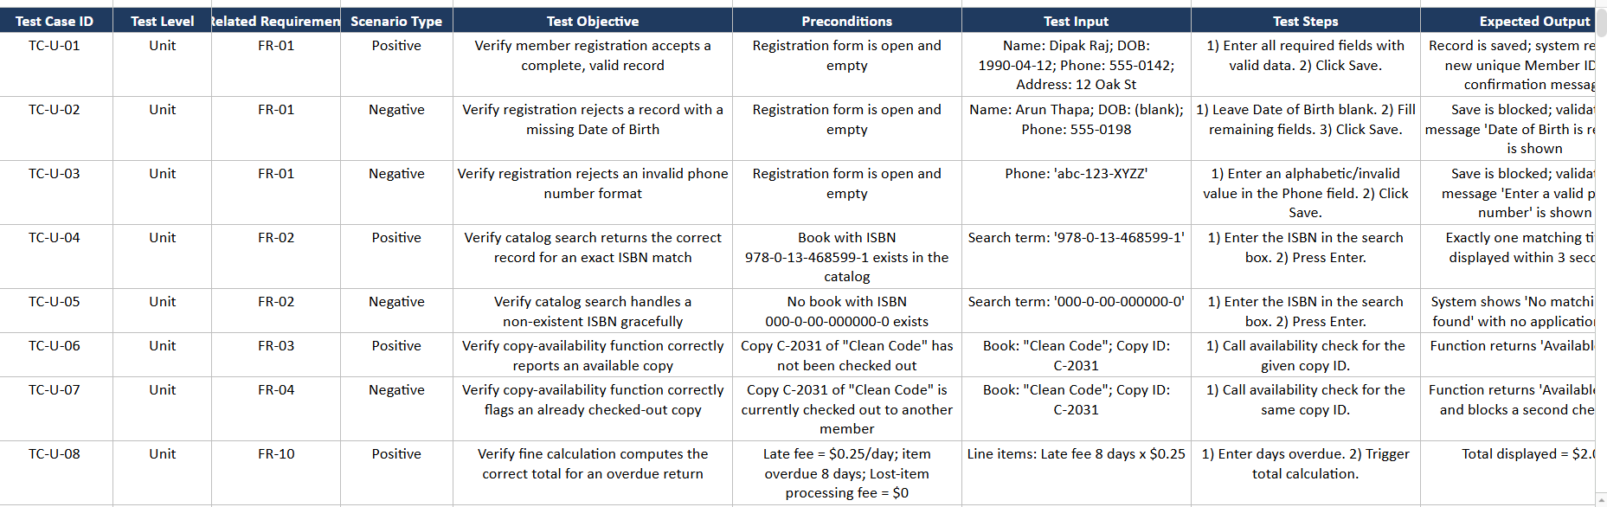
Figure 1
Unit Testing
Link of the Excel Document
https://docs.google.com/spreadsheets/d/1u_g03egv1DvQJuobr_v-wjB7AaX90AY-67BfVb8ixeU/edit?gid=0#gid=0
- Sheet 2: Integration Testing
The integration testing was performed to ensure the interactions among modules and the database.
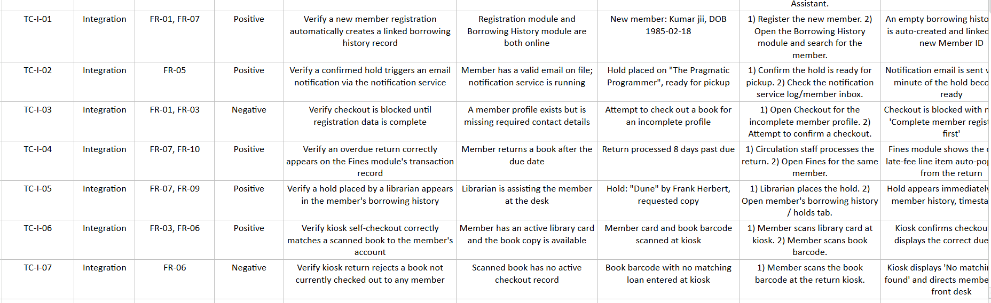
Figure 2
Integration Testing
Link of the Excel Document
https://docs.google.com/spreadsheets/d/1u_g03egv1DvQJuobr_v-wjB7AaX90AY-67BfVb8ixeU/edit?gid=1656065473#gid=1656065473
- Sheet 3: System Testing
System testing was conducted to check the overall working of the Library Management System and to ensure that all the modules of the Library Management System work together properly.
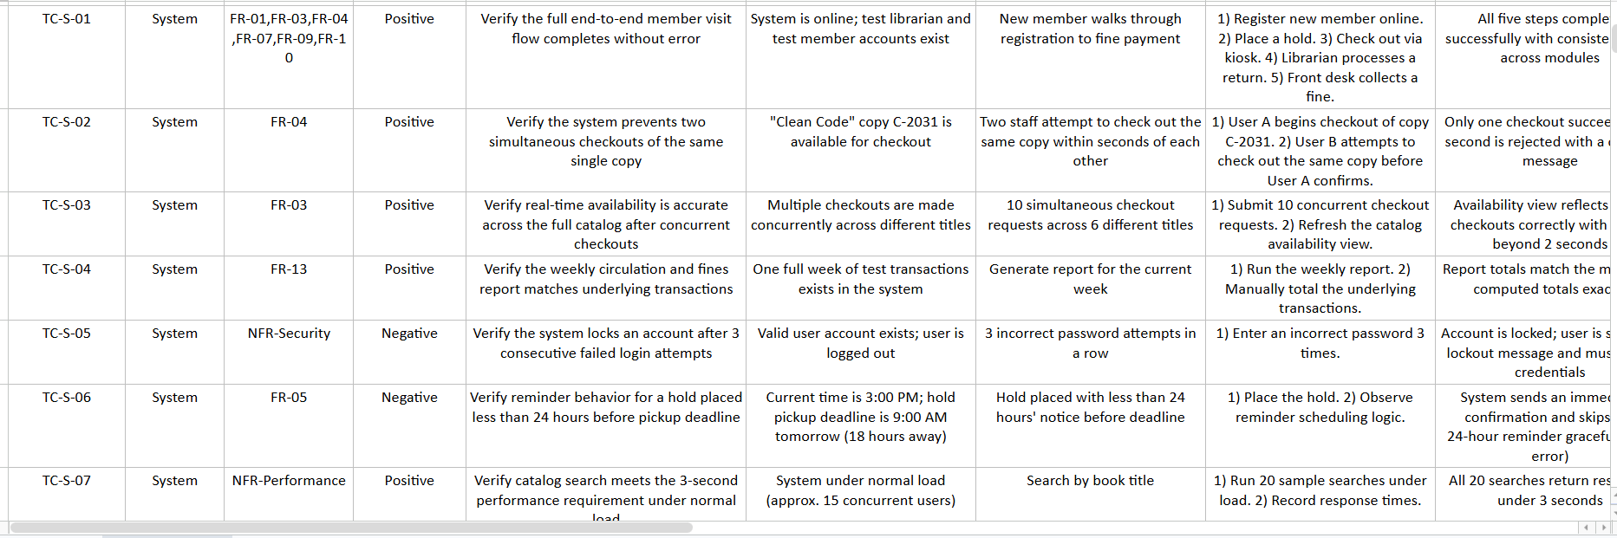
Figure 3
System Testing
Link of the Excel Document
https://docs.google.com/spreadsheets/d/1u_g03egv1DvQJuobr_v-wjB7AaX90AY-67BfVb8ixeU/edit?gid=1431683060#gid=1431683060
- Sheet 4: User Acceptance Testing
UAT (User Acceptance Testing) makes sure the system meets the user's requirements and functions as anticipated in real situations.
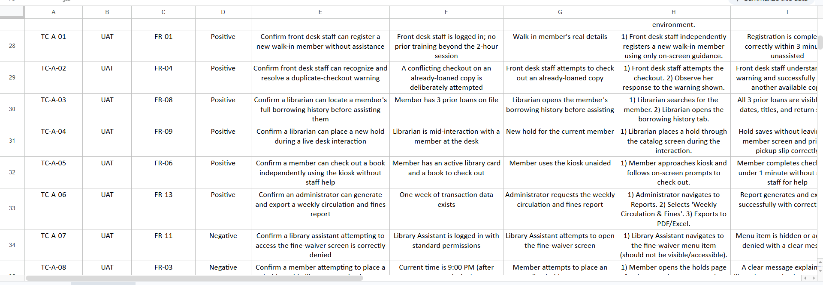
Figure 4
User Acceptance Testing
Link of the Excel Document
https://docs.google.com/spreadsheets/d/1u_g03egv1DvQJuobr_v-wjB7AaX90AY-67BfVb8ixeU/edit?gid=2010616267#gid=2010616267
Test Results Summary
Fourteen test cases were run on four testing levels. The outcomes showed that the User Registration and Login modules were successfully working as per the requirements of the system. Validation mechanisms were accurate in dealing with missing information, weak passwords, duplicate accounts, and incorrect login credentials. Database integration was successful, as was the authentication process. The features implemented were confirmed to be meeting the user needs and business needs during User Acceptance Testing.
Conclusion
Through the testing process, it was proved that the Library Management System's User Registration and Login modules are reliable in normal and exceptional situations. The system function, security and usability were extensively tested using unit testing, integration testing, system testing and user acceptance testing. The outcomes of all test cases were as per the expectations, thus the authentication component is ready to deploy. Performance testing, security testing, and load testing will be conducted in the future to further improve the quality and reliability of the system.

References
Pressman, R. S., & Maxim, B. R. (2020). Software engineering: A practitioner's approach (9th ed.). McGraw-Hill Education.
Sommerville, I. (2016). Software engineering (10th ed.). Pearson Education.
Myers, G. J., Sandler, C., & Badgett, T. (2011). The art of software testing (3rd ed.). John Wiley & Sons.

